Testing for Soil Types

Subject(s) Basic Science, Agricultural Science, Social Science

Year(s) 9

Learning Intention(s)
Students develop an understanding of the physical properties of soils, including structure, texture, bulk density and levels of air and water in the soil.

Curriculum links

Basic Science

Strand:

S9.1 Living Things and the Environment

Sub-strand:

S9.1.3 Biodiversity, Change and Sustainability

Learning Outcome(s)
- S9.1.3.1 Examine and describe the potential long-term effects of changes in biodiversity caused by human action on ecosystems and communicate ways of conserving ecosystems.

Agricultural Science

Strand: AS 9.3 Agronomy

Sub-strand: AS 9.1.3 Soils

Learning Outcome(s)
- 9.3.1.1 Recognise and evaluate soil by identifying and relating the four components of soil to soil use, husbandry practices and soil enhancement.
- 9.3.1.2 Relate the soil profile to the agricultural use of an area.

Social Science

Strand:

SS9.3 Place and Environment, SS10.3 Place and Environment

Sub-strands:

SS 9.3.1 Mapping

SS 10.3.1 Geography of Fiji

Learning Outcome(s)
- SS 9.3.1.2 Explore and justify the importance of conserving the fragile ecological environment and our National heritage to promote environmental responsibility.
- SS 10.3.1.1 Investigate the main features of physical geography and illustrate how they determine land use to maximise productivity

Teaching Activity
Note: This activity is adapted from Solomon Islands Year 10 Agriculture syllabus, 2015.

Materials required
- Soil samples sourced from different areas within the school – 4 samples
- Glass jars – 4
- ‘Soil Sample Observation’ handout – print 1 per student
- Soil triangle diagram (optional) – teacher copy to project, print or draw on board (optional)
- Library or internet access (if available at the school) for researching relevant topics

Engage: Class discussion introducing soil types
- Explain that for this activity, students will learn about the physical components of soils and how different soil types can impact soil productivity and fertility, affecting healthy plant growth.
- Provide some basic information about soils. For example:
Soil is a living, active, and life-giving natural resource that contains countless organisms in various sizes and forms. These soil micro-organisms formed the basis of a well-developed inter-dependent ecosystem.
A healthy soil should provide the environment clean air and water, crops and forests, pastures and fodders, wildlife, and beautiful landscapes.
Soil controls water content, sustains plant and animal life, filters and safeguards pollutants, cycles nutrients, and provides physical stability and support for human structures.
Maintaining the conditions of soil physical properties through maximizing the presence of living roots, micro-organisms, soil cover, biodiversity, as well as avoiding disturbance of the soil are key values in addressing sustainable use and productivity of the soil.

Explore: Soil and Farming
Conduct a class discussion on the following questions:
  - What current planting or farming practices are used in your school, village or community?
  - How do these practices affect soil physical properties or conditions around the area?
  - Ask students to draw the following table in their workbooks to record their observations:
 | Current practices | Effects on soil properties or conditions | Positive or negative effect
1
2
3
4

Explain: Information about soil texture
Provide information about soil texture. For example:
Soil is made up of three main particles: sand, silt, and clay.
Sand particles are large and coarse, and can be seen without the aid of a magnifying glass. Sand particles feel gritty or rough when rubbed between the thumb and fingers.
Silt particles are medium in size and feel like flour. When wet, silt feels smooth but not slippery or sticky. Silt particles are so fine that they can be seen only with the aid of a microscope.
Clay particles are fine and dense and can be easily shaped into a ball or ribbon when wet. Clay particles are slippery and sticky when wet but feel smooth and powdery when dry. Clay particles can be seen only with the aid of a powerful microscope.
The relative amount of sand, silt and clay particles in each sample determines the soil texture.
There are twelve soil types based on the distribution proportions of the main soil particles. The textural triangle (see diagram) assigns soil type based on distribution of sand, silt, and clays. The name of the section in which the two lines intersect is the class name of the soil in question. For example, a soil containing 15% clay, 20% silt and 65% sand is called sandy loam.

Elaborate: Determining soil texture
Conduct a class discussion of how to determine the texture of a given soil. There are three main methods:
  - The settling method, which observes the depth of the settling soil and the timing allowed for the concentration of particles to settle.
  - The feel procedure, which involves moistening the soil sample with water and rubbing it between thumb and fingers. How wet soil forms gives a good idea of the soil’s content and texture. Sand particles are gritty and will not form a ball, silt will break and not form a ribbon, and clay particles will form a ball or ribbon. Accuracy of this method depends largely on experience.
  - A throw-the ball test which involves throwing a ball of mud on a hard surface such as a wall or tree and checking to see the shot impact ie whether the ball spatters, sticks or holds its shape.
Explain to the students that generally, the best soil consists of medium-textured soil that contains an equal distribution of sand, silt and clay particles. Medium-textured soils are generally ideal for planting or farming, and are easily cultivated and highly productive for plant and crop growth. Furthermore, adding organic matter to such soil will help enhance stickiness, bind soils together and make the soil feel loamy.

Evaluate: Testing soil and recording results
- Students collect soil samples from four different locations within the school.
- They will determine the textures of the four soil types using the throw-a-ball test.

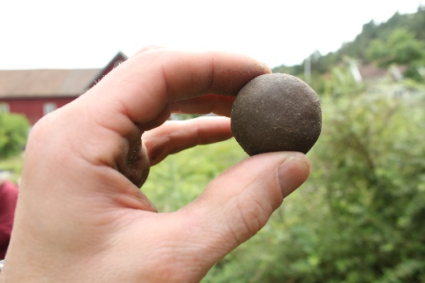
Instructions for conducting the throw-the ball soil test
Soil texture can be determined by the way the ball acts when you throw wet or dry soil balls against a hard surface, such as a wall or a tree.
Take a handful of soil, wet it and work it between thumb and fingers to the consistency of dough. Make a mud ball about 3cm in diameter. Throw the ball at a flat surface to evaluate its texture:
  - Coarse: splatters when either wet or dry.
  - Moderately coarse: shotgun pattern when dry and it holds its shape when wet.
  - Medium: shatters when dry and clings together when moist but does not stick to target.
  - Moderately fine: holds its shape when wet and sticks to the target but is easy to remove.
  - Fine: sticks well to the target when wet and becomes a very hard missile when dry.
- Students record data of their experiments for the four samples. Students can either use the template below to draw a table in their workbooks, or they may be provided with a worksheet handout.
 | Description of sample location | Description of how sample feels | Proposed soil type
1
2
3
4
- Students draw conclusions from the throw-the-ball tests, using the data collected. They then write two paragraphs in their workbooks relating the soil type to its location and describe how the soil is being used at the site. Students suggest if there might be better ways to use the soil type in that area.

Extend
- For each soil sample, a handful of soil is put into a separate glass jars containing 100 ml of water. Seal the jars with a tight-fitting lid and shake them for two minutes. Leave overnight for the soil to settle.
- Inspect the soil samples after each has settled to see if sand, silt and clay layers can be observed. Consider which layer will be at the top, the middle and at the bottom.

Soil Sample Observations

Name: ____________________
 | Description of sample location | Description of how sample feels | Proposed soil type, with reasons
Sample 1
Sample 2
Sample 3
Sample 4

Soil triangle diagram
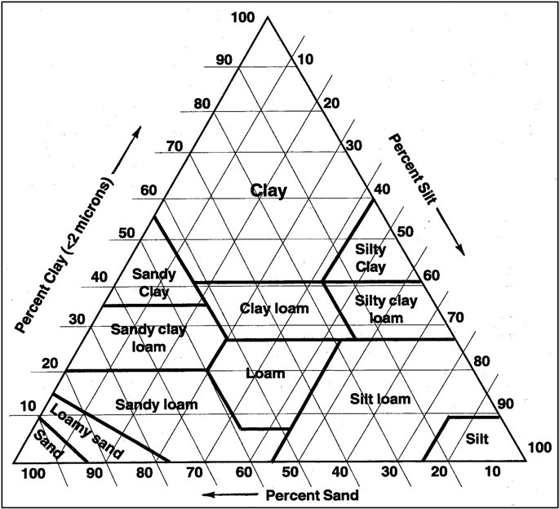
Credit: Florent Beck, CC BY-SA 4.0

