Studying the Rate of Germination

Subject(s) Basic Science, English

Year(s) 10

Learning Intention(s)
Students pose a question about seed germination and collect and interpret data to answer this question.

Curriculum links

Basic Science

Strand: S10.1 Living Things and the Environment

Sub-strand:

S10.1.2 Living Together

Learning Outcome(s)
- S10.1.2.1 Investigate and discuss growth and movement of organisms (plants) in response to their environment and describe feeding relationships that exist between organisms within a community

English

Strand: EN10.1 Listening and Speaking, EN10.3 Writing and Shaping

Sub-strands:

EN 10.1. 1 Text Types: media, everyday communication, literary texts

EN 10.3.4 Language Learning processes and Strategies

Learning Outcome(s)
- EN 10.1.1.1 Comprehend listening and speaking skills for a variety of purposes using a range of media texts
- 10.1.1.2 Use oral language accurately to communicate ideas and experiences appropriate to various situations and contexts.
- 10.3.4.1 Use a variety of writing strategies to develop a variety of writings.

Teaching Activity
Note: This activity is adapted from SAKG Literacy and Numeracy in the Kitchen and Garden – Ideas for Learning in Primary, p. 67

Materials required
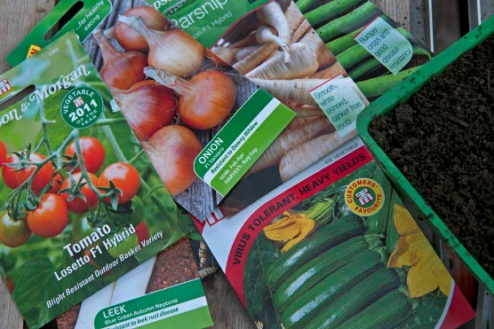
- Packets of herb or vegetable seeds that germinate quickly
(e.g. radish [fastest], cress, coriander, dill, basil, cucumber)
Credit: rhs.org.au
- Seed planting trays (adapt shallow plastic containers by making small drainage holes in the bottom) –
- Seed growing medium (soil or potting mix) – enough to fill the seed planting trays
- Small digging tools (cutlery can be used if it is washed carefully afterwards)
- Optional: spray bottles for watering the planting trays
- Sticks and labels for labelling seed types
- ‘Germination Observation’ handout – print 1 per student, ideally double-sided
- ‘Germination Data Analysis’ handout – print 1 per student, ideally double-sided

Activity 1: Engage interest in seed germination
- Introduce the concept of germination and show students pictures of the kinds of herbs/vegetables they will be growing.
- Distribute the ‘Germination Observation’ handout, 1 per student.
- Ask students to estimate:
  - how long it will take different seeds to germinate
  - the success rate they predict for the proportion of seeds that will germinate (e.g. 50% or 70%)
Students record their predictions on their ‘Germination Observation’ handout

Activity 2: Sowing the seeds
- Working in pairs or individually, students prepare the planting trays and sow the seeds, following packet instructions on depth and spacing. If multiple types of seeds are being used, sow several types in each planting tray.
Place trays in different locations around the school. For example, shady and unshaded; exposed or sheltered; inside or outside.

Activity 3: Observing germination
- Ensure that students water all the trays daily to keep the soil moist. If available, spray bottles for misting water onto the trays are useful for watering lightly.
- Optional variation: water some trays more or less than others, and note any effects on germination and growth.
- Allow time for the seeds to germinate.
- Each week, make formal observations of the trays. Students should observe and measure any developments. For example:
  - signs of germination
  - rate of growth
  - height of seedlings
  - proportion of seeds showing activity
  - variation between types of seed
  - comparisons between trays in different locations.

Activity 4: Analysing and presenting germination data
- At the end of 8 weeks, students study the data they have collected and use it to create graphs:
  - comparing germination speed and success rate for seed types
  - comparing germination speed and success rate for tray locations.
- Working in pairs or individually, students add their chart to the ‘Presenting Germination Data’ handout and write a short report explaining their findings:
  - relationship between environmental factors (tray location, regular watering) and slow or fast germination and growth
  - unexpected, interesting or disappointing variations in the germination rate.
Working in pairs or individually, students present their findings to the class, and make decisions about how, when and where to plant specific types of seed in the future.

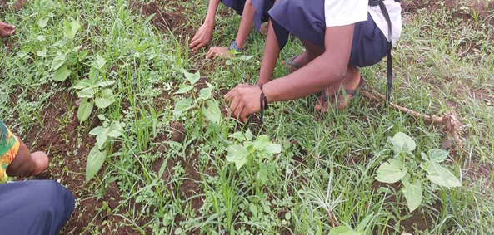
Activity 5: Optional planting activity
Credit: Navesau Adventist College
- If space and resources permit, plant out the seedlings into optimal locations based on student findings. Continue to nurture and observe the growth of the plants.

Germination Observations
Name ___________________________________
Germination Predictions
Seed type:
Germination time
Success rate
Weekly Observations (see overleaf for instructions)
Weekly Observations
Obs. Date | Tray location: |  | Date planted:
Obs. Date | Seed types:
1:
2:
3:
4:
5:
6:
7:
8:

Weekly Observations Instructions
Name ___________________________________
Complete a separate Weekly Observations table for each seed planting tray. Write the date of your observation, and aim for a total of 8 observations – 1 per week.
Record relevant information. For example: germination rates; seedling height; number and size of leaves; variations between plants. On a separate sheet, draw and date diagrams of what you see.
Weekly Observations
Obs. Date | Tray location: |  | Date planted:
Obs. Date | Seed types:
1:
2:
3:
4:
5:
6:
7:
8:

Germination Data Analysis
Name ___________________________________
- When your observations are complete, study your data and use it to create graphs:
  - Compare germination speed and success rate for seed types.
  - Compare germination speed and success rate for tray locations.
Graph A: Seed types
Graph B: Tray locations
- Reflect on your date and write a short report about what you’ve observed. For instance:
  - which environmental factors (e.g. tray location, regular watering) seemed to influence germination speed and success rate
  - which seed types were most and least successful
  - unexpected, interesting or disappointing variations in germination and growth.
Your Report on Germination
- Make recommendations about which locations are most suitable for the different seed types.
Your Recommendations about Seed to Plant, and Where

