Conducting the Ultimate Growth Challenge

Subject(s) Basic Science, Mathematics, Basic Technology

Year(s) 9

Learning Intention(s)
Students will apply their knowledge of gardening, plant biology and sustainable agriculture to design and implement different growing techniques in a friendly competition. They will develop problem-solving, teamwork and critical thinking skills while testing real-world gardening strategies.

Curriculum links

Basic Science

Strand: S9.1 Living Things and the Environment

Sub-strand:

S9.1.3 Bio-diversity, Change and Sustainability

Learning Outcome(s)
- S 9.1.3.1 Examine and describe the potential long-term effects of changes in biodiversity caused by human action on ecosystems and communicate ways of conserving ecosystems.

Mathematics

Strand: M 9.1 Basic Mathematics

Sub-strands:

M9.1.4 Consumer Arithmetic

M9.1.5 Measurement

Learning Outcome(s)
- M9.1.4.1 Study real-life problems related to Mathematics.
- M9.1.5.1 Explore measurement

Basic Technology

Strand: BT9.3: Design and Enterprising

Sub-strand:

BT9.3.2 Enterprising Skills

BT 9.6 Woodworking Joints

Learning Outcome(s)
- BT 9.3.2.1 Develop an enterprising project and calculate costs involved.
- BT 9.6.1.1 Explore woodworking joints and develop practical skills in construction of woodworking joints.

Teaching Activity

Materials required
The materials are determined by student planning, and are likely to include:
- Construction materials (e.g. logs, bricks, tyres)
- Soil, compost and potting mix
- Seeds
- Fencing (if required)

Step 1: Forming Growth Challenge Teams
Divide the class into teams of 3–5 students. Each team must give themselves a garden-related team name (e.g. ‘Green Giants,’ ‘Soil Masters,’ ‘Sprout Squad’)

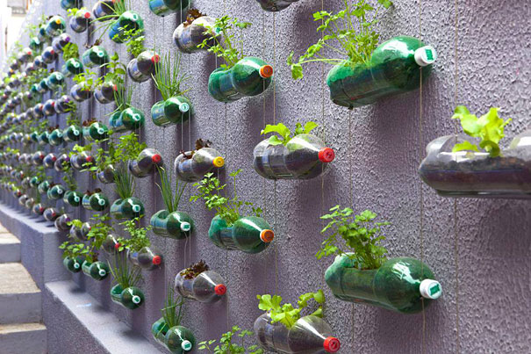
Step 2: Selecting a Gardening Technique
Credit: Flickr (NguyenTanTin CC BY-NC 2.0)
Teams choose or are assigned a different gardening technique, such as:
- vertical gardening
- companion planting
- no-dig gardening
- hydroponics
- raised bed gardening
- traditional row planting

Step 3: Designing and Planning
Teams research their chosen method and create a basic plan, including plant choices, watering schedule, and soil treatment.

Step 4: Planting and Growing
Teams set up their garden and begin caring for their plants. They must document their process through a growth journal (e.g. photos, measurements, observations).

Step 5: Surprise Challenges!
Every few lessons, introduce an unexpected challenge to encourage problem-solving:
- Pest Attack! Teams must research and apply natural pest control methods.
- Drought Week! Limited water supply – who can conserve moisture best?
- Super Growth! Introduce a new nutrient or compost option for teams to test.

Step 6: Evaluating
After a set period (allow time for significant plant growth), teams will present their results. Criteria may include:
- plant health and growth rate
- crop yield (if applicable)
- sustainability and efficiency of the method used
- creativity and teamwork

Winning Categories (Optional)
🏆 Best Overall Crop Production – Highest yield and healthiest plants
🏆 Most Sustainable Method – Strong results with lowest use of water and resources
🏆 Most Innovative Design – Most creative approach to gardening
🏆 Best Teamwork and Documentation – Clear journal and great teamwork

