Growing Food from Garden to Table

Subject(s) Basic Science, Mathematics, English, Home Economics

Year(s) 9

Learning Intention(s)
Students will investigate the journey of food from seed to plate by growing, harvesting and preparing ingredients from the school garden. Through this process, they will develop an understanding of plant biology, sustainability, nutrition and cultural connections to food while applying teamwork and problem-solving skills.

Curriculum links

Basic Science

Strand: S9.1 Living Things and the Environment

Sub-strand:

S9.1.1 Structure and Life Processes

Learning Outcome(s)
- S9.1.1.2 Account for the structure and function of plants parts that relate to life processes and demonstrate these processes using controlled experiments
Mathematics

Strand: M9.1 Basic Mathematics

Sub-strand:

M9.1.4 Consumer Arithmetic

M9.1.5 Measurement

Learning Outcome(s)
- 9.1.4.1 Study real-life problems related to Mathematics.
- 9.1.5.1 Explore measurement.
English

Strand: EN 9.1. Listening and Speaking

Sub-strand:

EN9.1.1 Text types: media, everyday communication, literary texts

Learning Outcome(s)
- EN9.1.1.2 Demonstrate concepts, skills and values respective to listening and speaking skills and relate it to a range of everyday conversation.
Home Economics

Strand: HEC 9.2 Food and Nutrition

Sub-strand: HEC 9.2.6 Food planning and Product development

Learning Outcome(s)
- HEC 9.2.6.1 Design nutritious meals using appropriate food preparation skills and methods

Teaching Activity

Activity Overview
Over approximately 12 weeks, students will work in small groups to grow, analyse and cook a food, and present the process. The activity is divided into three phases:
- Phase 1 – Grow It: Research and plant a seasonal vegetable or herb in the school garden.
- Phase 2 – Harvest and Analyse: Track growth, collect data on soil health and plant development, and research the nutritional value of their chosen produce.
- Phase 3 – Cook and Present: Prepare a simple dish using their harvested ingredients and present their process, including environmental impact and cultural connections.

Materials required

Phase 1 – Grow It
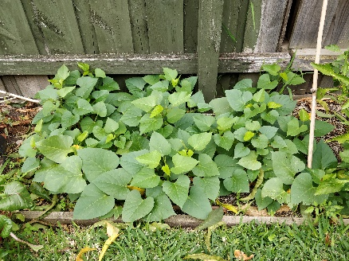
- Gardening gloves
Credit: Flickr (Alpha CC BY-NC 2.0)
- Trowels and hand shovels
- Watering cans or hose
- Garden beds or pots
- Compost and soil mix
- Seeds or seedlings (seasonal vegetables and herbs)
- Garden markers for labelling plants
- Rulers or measuring tape (to track plant growth)
- pH testing kit for soil analysis (optional)

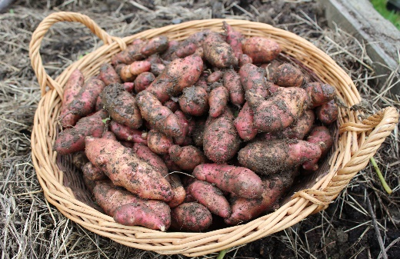
Phase 2 – Harvest and Analyse
Credit: Local Food Initiative
- Notebooks for recording observations
- Digital cameras or tablets (for progress photos) (optional)
- Scales (to measure harvested produce)
- Magnifying glasses (for plant examination)
- Reference books or online resources on plant biology and nutrition

Phase 3 – Cook and Present
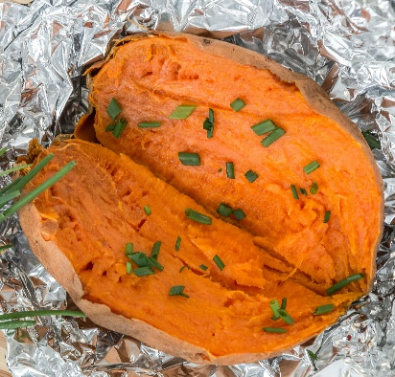
- Ingredients from the garden
- Knives and chopping boards
- Mixing bowls and utensils
- Cooking appliances as required (e.g. portable stove, blender)
- Plates, bowls and cutlery
- Recipe print-outs or digital copies
- Presentation materials (e.g. poster boards, butchers paper, laptops for slideshows)

Introduction
Credit: Pexels (Loren Castillo)
Explain the activity to students and divide students into groups of 3–4.

Phase 1 – Grow It
Student group activities
- Select a plant appropriate for the season and location, and research its growth needs. Use the Seasonal Planting Calendar for guidance.
- Prepare the garden bed, plant seeds or seedlings, and create a watering and care schedule.
- Record progress in a workbook, with photos, sketches measurements and notes.
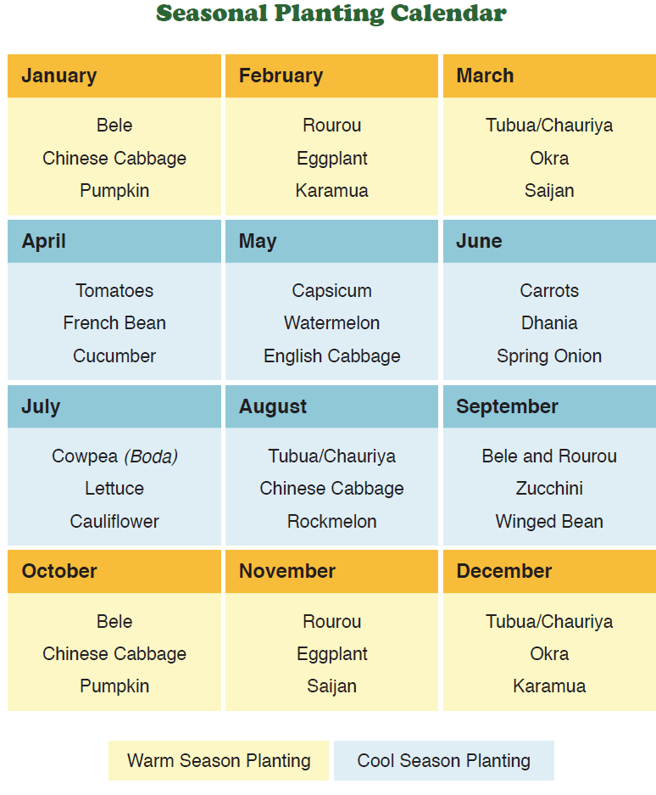Source: Food and Health Guidelines for Fiji 2013 (by World Health Organization, Fiji Ministry of Health, and National Food and Nutrition Centre,

Phase 2 – Harvest and Analyse
Student group activities
- Measure plant growth and observe changes.
- Test soil samples for pH and nutrient levels (if equipment available).
- Research the nutritional benefits of the produce and discuss sustainability factors (e.g. food miles, organic/non-organic).

Phase 3 – Cook and Present (Weeks 1–12)
- Develop a simple recipe featuring their harvested ingredient.
  - Optional – student groups or the whole class could work together to combine ingredients.
- Cook the dish (either in a school kitchen or as a no-cook option, such as a salad or herbal tea).
- Discuss and present their dish to the class, explaining:
  - the science behind plant growth
  - the environmental impact of growing food locally
  - any cultural or historical significance of their chosen ingredient.

Extension and Cross-Curricular Links:
- Science: Photosynthesis, soil health, and plant biology.
- Maths: Measuring growth rates, calculating food miles.
- Geography: Climate and soil conditions affecting food production.
- Health and PE: Nutritional benefits of fresh produce.
- Food Technology: Cooking skills and food presentation.

Outcome and Reflection
Students will reflect on what they learned about food sustainability, health, and teamwork. They could document their journey in a video diary or digital portfolio.

