Examining Micro-Organisms in Composting

Subject(s) Basic Science

Year(s) 9–10

Learning Intentions
Students will:
- Identify the specific roles of bacteria, fungi and actinomycetes in composting.
- Observe and understand how microbial activity drives decomposition.
- Appreciate the ecological importance of micro-organisms in nutrient cycling and sustainable waste management.
- Link the science of microorganisms to real-world applications such as gardening and agriculture.

Curriculum links

Basic Science

Strand: S9.1 Living Things and the Environment, S10.1 Living Things and the Environment

Sub-strands:

S9.1.2 Living Together.

S10.1.2 Living Together

Learning Outcome(s)
- S9.1.2.2 Explore the wide variety organisms in the ecosystems and show their interdependence as a means of survival.
- S10.1.2.1 Investigate and discuss growth and movement of organisms (plants) in response to their environment and describe feeding relationships that exist between organisms within a community

Teaching Activity

Materials required
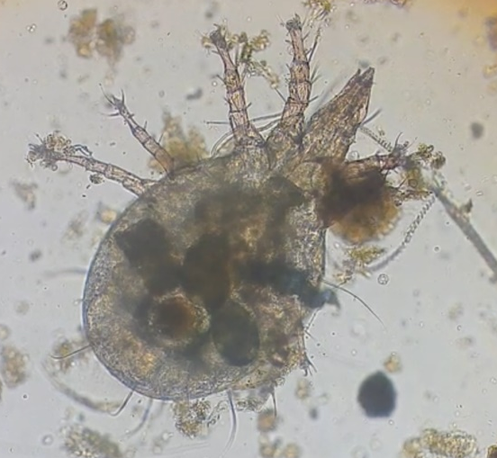
- ‘Microbial Activity Observations’ handout – print 1 per student, ideally double-sided
- Video: Inside a Drop of Compost, YouTube, 4m:48s (if resources allow)
- PowerPoint: Teacher to create a presentation using images included in this document:
  - Compost Food Web
  - Images from Inside a Drop of Compost video, inserted into PowerPoint (if video cannot be used)
- Glass jars, identical, with lids (e.g. mason jars) – minimum 2 jars
- Organic material (e.g. vegetable scraps, fruit peels)
- Sterile sand or potting mix (for the no-microbe environment)
- Soil (from a garden or compost pile, rich in micro-organisms)
- Gloves
- Spray bottle with water
- Measuring cups
- Sticky labels or masking tape for jar labels
- Access to a microscope (optional, for observing microbes directly)

Activity 1: Introduction (15 minutes)
- Begin with a short discussion about microorganisms:
  - Bacteria: The primary decomposers in composting, breaking down sugars, proteins, and starches.
  - Fungi: Responsible for breaking down tougher materials like cellulose in plant matter.
  - Actinomycetes: Specialised bacteria that decompose complex compounds including lignin, giving compost its earthy smell.
- Show students the compost microorganisms handout and, if resources allow, watch video, Inside a Drop of Compost (4m48s). If video is not available,
- Ask students to pair-share the following questions:
  - Why is it important to have a variety of microorganisms in composting?
  - What do you think would happen to the composting process if one group of microorganisms (e.g. fungi) were missing?
- Explain how the next activity will test the role of these microbes in decomposition.

Activity 2: Setting up the experiment (20 minutes)
A minimum of two jars is required. If more jars are available, the experiment can be duplicated in several pairs of jars, allowing for further comparison.
- Label the jars: ‘With Microbes’ and ‘Without Microbes’.
- Half-fill the ‘With Microbes’ jar with soil.
- Half-fill the ‘Without Microbes’ jar with sand.
- Add equal amounts of organic material (e.g. half cup of fruit/vegetable scraps) to each jar.
- Lightly spray water into both jars to moisten the contents. It should feel damp but not soggy.
- Loosely close the jar lids to allow air exchange while preventing contamination.

Activity 3: Observing microbial activity (weekly, for 4 weeks)
Each week, students will use their ‘Microbial Activity Observations’ handout to take notes on the following observations:
  - changes in the organic material (e.g. texture, size, colour)
  - signs of microbial activity, such as fungal growth (white filaments), heat (from bacteria), or earthy smells (from actinomycetes)
  - differences between the jars.

Optional Activity: Microscope observations
- Use a microscope to examine a small sample of soil from the ‘With Microbes’ jar.
- Identify visible structures such as fungal hyphae or bacterial colonies.

Activity 4: Final analysis and discussion (30 minutes)
- After 4 weeks, open the jars and compare the decomposition in each.
- Discuss:
  - How did microbes in the soil impact decomposition compared to the sand?
  - What types of micro-organisms might have been active in the decomposition process?
  - How do these micro-organisms contribute to nutrient recycling and soil health?
- Relate findings to real-world composting and the importance of maintaining healthy microbial populations.
- Discuss:
  - Can you think of ways to ensure that these micro-organisms thrive in a compost bin? What environmental conditions do they need?
  - Have you seen or smelled compost that has gone bad? How might a lack of certain microorganisms contribute to this?

Extended learning
- Role of oxygen and temperature
Discuss how aerobic bacteria need oxygen to break down materials and how their activity generates heat, creating optimal conditions for thermophilic bacteria.
- Microbial food preferences
Research which microorganisms thrive on different types of organic material. For example, fungi prefer woody material, while bacteria break down sugars and proteins.
- Human benefits of compost microbes
Explore how compost microbes improve soil structure, retain moisture, and support plant growth when compost is added to gardens.

Compost Food Web
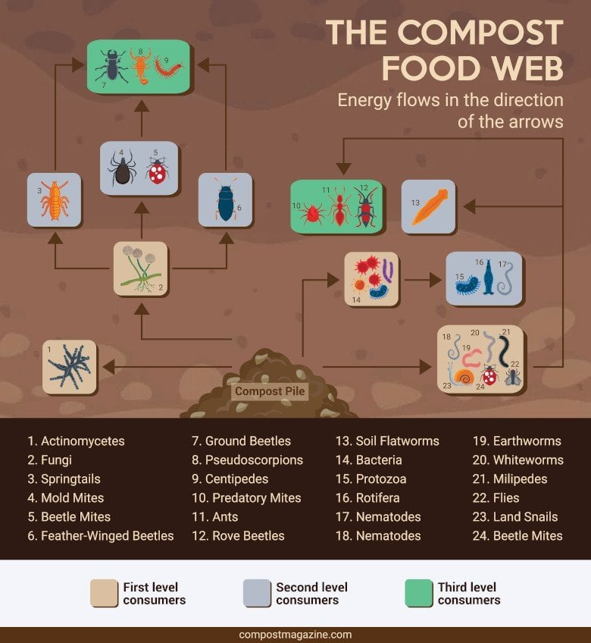
Credit: Compost Magazine, CC-BY 4

Images from Inside a Drop of Compost video [insert into PowerPoint if video cannot be shown]
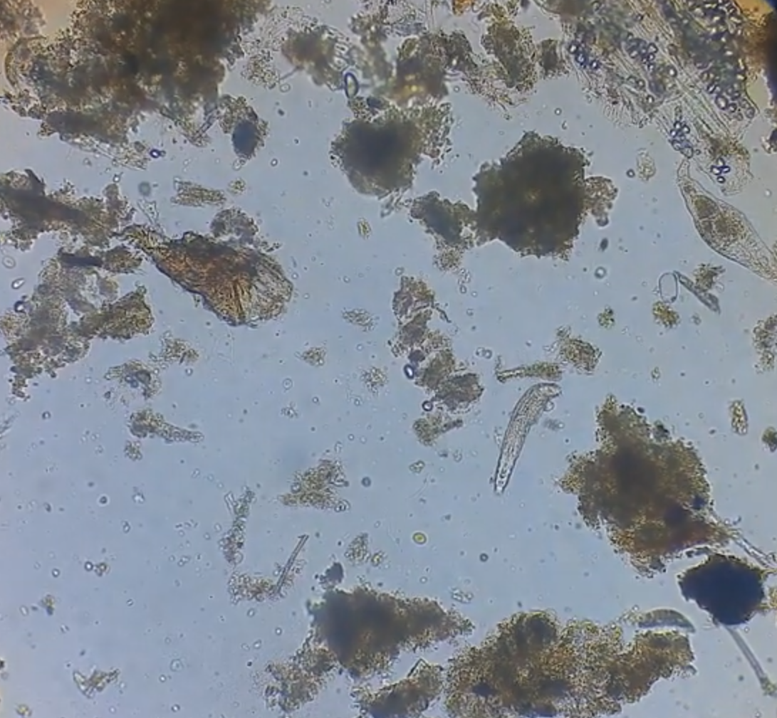

Images from Inside a Drop of Compost video [insert into PowerPoint if video cannot be shown]
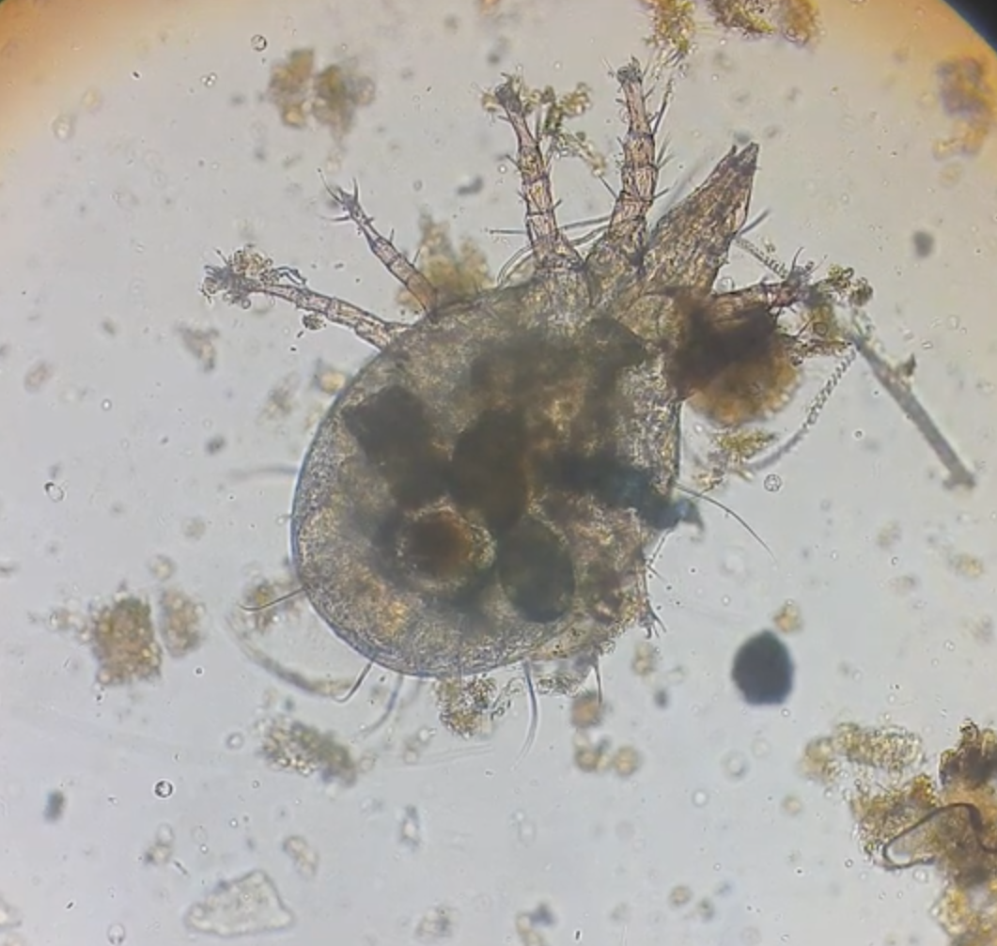

Microbial Activity Observation
Name ___________________________________
- Observe and record changes in the organic material (e.g. texture, size, colour).
- Note signs of microbial activity, such as fungal growth (white filaments), heat (from bacteria), or earthy smells (from actinomycetes).
Week | Jar 1: With Microbes | Jar 2: Without Microbes
1
2
3
4

